Career Coach Guide

This document meant to help you with your completion of the tasks listed below on www.highline.edu/careercoach
- Click 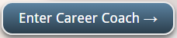

How to Research a Specific Career or Job
This yields information about what a person in the job or career do such as daily tasks, education required for the job or career, salary, growth, and employers that people in this field.
- Click on the Careers tab
- Type in the job or career that you would like to learn more about in the Search bar
- Click 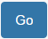 button or hit Enter
- Choose the result that best matches what you are looking for
*You are able to localize your job or career information to a specific area or region. Please refer to “Changing the Region”

Research Jobs Based on a Specific Degree
This yields results of jobs people with this degree have
- Click on the Degrees tab
- Type in the degree you wish to find jobs for in the Search bar
*You are able to localize your job or career information to a specific area or region. Please refer to “Changing the Region”
To Find Careers the fit you the Best
The Career Assessment is for people who have no idea what career field they would like to work in. The assessment helps students to explore some jobs that matches with the personality the career assessment determined you match best. The personality types you are assessed for are Realistic, Investigative, Artistic, Social, Enterprising, and Conventional.
- Click on the Career Assessment tab
- You can either take the short or longer assessment.
- Click Get Started to take the short assessment OR Take a longer assessment for the long assessment
- Once you’ve completed it and your results appear, scroll down to the bottom and click View Results to see the jobs and careers that match your personality the best.
Changing the Region
Picking your region allows you to customize the career data displayed on this site (employment, wage, etc.) meaning all the career data is from the geographical area you specified, plus surrounding areas within the distance you specify.
The following actions are to take place once you are viewing a specific job and will require you to login.
- Click on 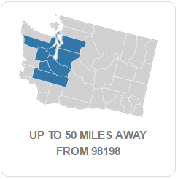 to the right side of the job information section
- Login if you haven’t already
- Change the Radius by clicking on the drop down menu.
- Click Update.

